COVID-19 Update: April 14, 2020
This is a daily joint communication from the Logan County Department of Public Health and Abraham Lincoln Memorial Hospital updating you on the status of coronavirus (COVID-19) in Logan County. This communication will come each day as necessary.
A confirmed positive case from Mason County is still hospitalized at Abraham Lincoln Memorial Hospital.
The total number of confirmed cases in Logan County is 4. Two Logan County residents have been reported as recovered from COVID-19. A recovered individual is someone who has tracked their symptoms twice daily and reported that they have been symptom-free for 72 hours to the Logan County Department of Public Health
Abraham Lincoln Memorial Hospital Inpatients
As of 2:30pm
COVID-19 Positive NEW TODAY | COVID-19 Persons Under Investigation (PUI) | COVID-19 Deaths
0 | 3 | 0

A person under investigation (PUI) is an ALMH inpatient who has been tested and is awaiting the results of their COVID-19 test. ALMH outpatient patients and hospital inpatients who have been discharged or transferred to another healthcare facility are not included in these numbers.
Logan County Data
The table below represents Logan County residents. This information is updated regularly by the Logan County Department of Public Health and is available at www.lcdph.org. The discrepancy between the number of inpatients at Abraham Lincoln Memorial Hospital in the table above and the LCDPH table below is because ALMH may be caring for patients from outside of Logan County.
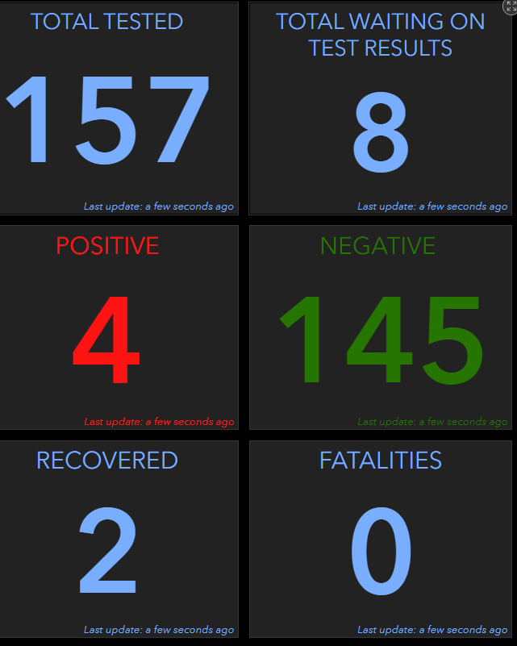

Statewide Data
A continually updated map of statewide data is maintained by the Illinois Department of Public Health and available online at: https://www.dph.illinois.gov/topics-services/diseases-and-conditions/diseases-a-z-list/coronavirus

